**Online Appendix**

The online appendix contains information on all model inputs (Section A), details of the model design (Section B), information about the student surveys (Section C), and additional sensitivity analyses (Section D).

Those who wish to use the model as a decision aid for re-opening their university in the fall should visit our [website](https://www.publichealth.columbia.edu/academics/departments/health-policy-and-management/openup-model).

**A. Complete list of Model Inputs.**

**Online Table 1** lists additional parameters used in the model as well as details surrounding how they were calculated.

|  |  |  |  |
| --- | --- | --- | --- |
| **Online Table 1**. Total costs and probabilities used as model inputs for estimating the cost-effectiveness of strategies to improve infection control for Covid-19 in a university setting with 16,000 students and 4,500 employees on campus during a 90-day semester. | | | |
| Parameters | Baseline | Distribution* | Source |
| *Population* |  |  |  |
| Number of students on campus | 16,000 | - | Data from Columbia University |
| Number of staff/faculty on campus | 4,500 | - | Data from Columbia University |
| *Daily number of close contacts* |  |  |  |
| Between each student and other students on campus (but not in dorms) | 2 | Triangular (1, 3, 2) | Expert opinion† |
| Between each student and staff/faculty on campus | 0 | Triangular (0, 1, 0) | Expert opinion† |
| Between each student/staff/faculty and community members outside of campus | 3 | Triangular (2, 4, 3) | Expert opinion† |
| Between each staff/faculty and students on campus | 1 | Triangular (0, 2, 1) | Expert opinion† |
| Between each staff/faculty and other staff/faculty on campus | 1 | Triangular (0, 2, 1) | Expert opinion† |
| Between each staff/faculty and community members outside of campus | 2 | Triangular (1, 3, 2) | Expert opinion† |
| *Probabilities and rates* |  |  |  |
| Transmission rate per close contact‡ | 0.066 | Normal (0.066, 0.005) | 1 |
| Proportion of affiliates immune to COVID-19 | 0.06 | Triangular (0, 0.2, 0.06) | 2 |
| Progression time for Covid-19 |  |  |  |
| Incubation time ($r_{inc}$) | 5 days | Triangular (3, 14, 5) | 3,4 |
| Time from infectiousness to symptoms onset ($r_{s}$) | 2 days | Triangular (1, 3, 2) | 3,4 |
| Time from exposure to infectiousness | 3 days | Probability distribution of $r_{inc}$- probability distribution of | 3,4 |
| Duration of infectiousness from symptoms onset | 9 days | Triangular (6, 11, 9) | 3,4 |
| Proportion of symptomatic cases among all exposed people (including the ones initially asymptomatic but became symptomatic eventually) | 0.53 | Beta (52.53, 59.23596) | 5 |
| Infection hospitalization rate among students | 0.008 | Beta (99.192, 12299.81) | 6,7 |
| Infection hospitalization rate among staff/faculty | 0.018 | Beta (98.182, 5356.374) | 6,7 |
| Infection fatality rate among students | 0.0002 | Beta (99.9798, 499799) | 6 |
| Infections mortality rate among staff/faculty | 0.0015 | Beta (99.8485, 66465.82) | 6 |
| Proportion of students’ compliance with stay-home order when they notice their symptoms | 0.85 | Triangular (0.75, 0.9, 0.85) | Assumption |
| Proportion of community members’ compliance with wearing masks outside of campus | 0.78 | Triangular (0.72, 0.78, 0.78) | 8,9 |
| *Direct costs (U.S. dollars in 2020 USD)* |  |  |  |
| Hospitalization | $23,489 | - | 10,11 |
| Funeral cost for infection death | $10,000 | Gamma (16, 0.0016) | Assumption |
| Intervention costs¶ |  |  |  |
| CDC guidelines |  |  | 12 |
| Adhering to cleaning protocol costs | $318,798 | - | 13 |
| Custodial staff | $979,503 | - | 13 |
| Personal protective equipment | $1,386,898 | - | 13 |
| Enhanced masks | $164,000 | - | 2 masks/affiliate @$4/mask. Enhanced masks are provided on top of regular masks. The number here only reflects the cost of providing enhanced masks. |
| Temperature cameras | $485,000 | - | 10 units @ $12,000/unit and installment cost of $500/unit. In addition, assuming wage for 20 staff operating 8 hrs/day over the entire semester at the rate of $25/hr. |
| PCR test (per test) | $31 | - | Internal data for test cost. In addition, assumed personnel time value for 4 personnel at $25/hr for 8 hrs/day for 1500 tests; 30% administrative costs; 10 cents shipping/specimen. |
| Far UVC lights | $3,630,000 | - | $1,000/light + $100 installation, 3,300 lights installed |
| HVAC Upgrades | $12,000,000 | - | Cost for Columbia University¶ |
| *Indirect costs (U.S. dollars in 2020 USD)* |  |  |  |
| Productivity loss for Covid-19 (per person) | $2,800 | Gamma (100, 0.03571429) | Assuming 14 days of quarantine at $25/hr for 8 hrs/day |
| Productivity loss for infection hospitalization (per person) | $4,200 | Gamma (100, 0.02380952) | Assuming 21 days of quarantine at $25/hr for 8 hrs/day |
| Productivity loss for infection death (per student) | $1,950,000 | Gamma (100, 5.128205e-05) | Assuming 39 yrs (65-26) work years lost at $50,000/yr. 26 represents the average age of students at Columbia University |
| Productivity loss for infection death (per staff/faculty) | $950,000 | Gamma (100, 0.0001052632) | Assuming 19 yrs (65-46) work years lost at $50,000/yr. 46 represents the average age of staff/faculty at Columbia University |
| Lost tuition per day† for online vs. in -person classes (per student) | $46 | - | Calculated from a student survey average tuition for the Fall of 2020 semester at Columbia University |
| Productivity loss associated with a false-positive test result (per staff/faculty per day) | $450 | Gamma (100, 0.2222222) | Assuming losing 18 hrs of leisure time at $25/hr |
| *Intervention effects* |  |  |  |
| CDC guidelines |  |  |  |
| Odds ratio of infection for hand washing/sanitizer | 0.45 | - | 14 |
| Odds ratio of regular mask use | 0.33 | - | 14,15 |
| Overall effect (odds ratio) | 0.1485 | Beta (85.0015, 487.3992) | 14,15 |
| Symptom checking application± |  |  |  |
| % improvement in proportion of students’ compliance with stay-home order when they notice their symptoms | 10% | Triangular (0.75, 0.9, 0.85)+0.1 | Assumption |
| Enhanced masks |  |  |  |
| Risk reduction hand sanitizer | 0.45 | - | 14,15 |
| Risk reduction N95 (relative to no mask) | 0.09 | - | 14,15 |
| Overall effect (odds ratio) | 0.04 | Beta (95.9095, 2272.226) |  |
| Test for SARS-CoV-2 |  |  |  |
| Sensitivity | 0.95 | - | 16 |
| Specificity | 0.95 | - | 16 |
| Temperature camera (fever) |  |  |  |
| Sensitivity | 25.8 | - | 17,18 |
| Specificity | 0.71 | - | 18 |
| *Health-related quality of life* |  |  |  |
| Losses of QALYs for Covid-19 among students | 0.09 | Beta (90.91, 919.2011) | 19 |
| Losses of QALYs for Covid-19 among staff/faculty | 0.14 | Beta (85.86, 527.4257) | Estimated for average age of staff/faculty at Columbia University (46 years old)19 |
| Losses of QALYs for hospitalizations | 0.6 | Beta (39.4, 26.26667) | 19 |
| Lifetime losses of QALYs for an infection death among students | 45.9 | (54)*Beta (14.15, 2.497059) | Assuming an average age student (26 years) would have otherwise lived for 80 years at QALYs of 0.85 estimated from average US population.19 |
| Lifetime losses of QALYs for an infection death among staff/faculty | 28.9 | (34)*Beta (14.15, 2.497059) | Assuming an average age staff/faculty (46 years) would have otherwise lived for 80 years at QALYs of 0.85 estimated from average US population19 |

Note: A close contact is defined as person-to-person contact < 6 feet for > 10 minutes. See Online Appendix for further details on model inputs.

*For triangular distributions, the values listed are baseline value, high, and low. For normal, beta, and gamma distributions, the values listed are the baseline value and error. Some variables had little influence on the model (indicated with a hyphen) and were removed from the Monte Carlo simulation to reduce computing time.

†Expert opinion based on video conferences with the Public Health Committee at Columbia University, which is comprised of a range of infectious disease experts and administrators.

‡The transmission rate assumes that half of close contacts will be at home and half of close contacts will be off campus.

¶Costs reflect actual costs paid by Columbia University including personnel.

**B. Additional Model and Intervention Details.**

**Status quo arm with and without closure events**

The status quo arm of the model takes two forms. In one, the model is allowed to predict the progression of disease each day with no control procedures in place other than local mask use. This form of the status quo arm is used for calculating total cases, hospitalizations, and deaths among university affiliates under local prevalence conditions and mask use behaviors. It not only allows for a pure “baseline scenario,” it also serves as structural validation for the model because the results can be roughly replicated on a spreadsheet.

In the second form, the model is stopped when cases reach 500 or when a super-spreader event occurs. The full code for the model is available on our website.

On any given day, we modeled the probability of Covid-19 exposure among population unit (being students vs. staff/faculty). Students and staff/faculty were treated as two separate populations with different baseline age, average number of close contacts (both on and off campus), involvement in risky events such as participation in community parties, and separate risks of illness, hospitalizations, and death due to Covid-19.

The probability of exposure was calculated based on average number of close contacts (both on and off campus), estimated prevalence of infectious cases outside of campus, time-dependent prevalence of symptomatic and asymptomatic infectious cases among students and staff/faculty in campus, and average transmission rate per close contacts.

A proportion of exposed individuals was assumed to become symptomatic infectious and the rest would become asymptomatic with a different rate of infectiousness. Every exposed individual was modeled in three consecutive phases of diseases progression: 1) time between primary exposure and infectiousness; 2) time between infectiousness and onset of symptoms; and 3) time from symptoms onset until the end of the infectiousness period. Unlike asymptomatic cases, a proportion of symptomatic individuals were assumed to self-quarantine for 14 days as soon as the appearance of their symptoms. This proportion was assumed to be 80% under no guidelines and 90% with addition of the symptoms checking mobile application.

We calculated the probability of exposure as follows:

where and respectively represents the probability of no exposure in local community outside of campus and the probability of no exposure inside campus for the population unit (students vs. staff/faculty) at time ; represents the active prevalence of Covid-19 (showing the number of active infectious people) in local community outside of campus at time ; and respectively represents the prevalence of symptomatic and the prevalence of asymptomatic Covid-19 among students at time ; similarly, and respectively represents the prevalence of symptomatic and the prevalence of asymptomatic Covid-19 among staff/faculty at time ; is the transmission rate per close contact; , represents the average number of daily close contacts that each unit (students vs. staff/faculty) has in local community outside of campus; , and represents the average number of daily close contacts that each unit (students vs. staff/faculty) has with another student, and with another staff/employee, in campus, respectively; is the compliance rate with wearing face masks in local community outside of campus; is the risk reduction associated with wearing face masks; and represents respectively the average number of exposed individuals who will become symptomatic, and who will become asymptomatic, among population unit (students vs. staff/faculty) at time ; is the number of susceptible individuals in population unit (students vs. staff/faculty) at time and and represents respectively the proportion of exposed people who will become symptomatic, and who will become asymptomatic.

We modified the risks of infection above by applying the adjusted odds ratios associated with different interventions of our study. Based on average number of students/staff exposed every day in the model, we calculated the rates of hospitalizations, deaths, direct medical costs, indirect medical costs, opportunity costs of online vs. in-person teaching, and losses of QALYs.

In addition, every day, we modeled the probability of a super-spreader event based upon the prevalence of infectious cases of disease in the community (), a standard gamble-based risk assessment administered to students that revealed students’ preferences for participation in community parties ( as the daily probability of students’ participation in a community party), and the average number of attendees in a community party (). We calculated the probability of a super-spreader event as follows:

Where we multiplied by 0.1 as it is shown that 10% of exposed cases are, on average, responsible for 80% of subsequent infections. In the absence of more granular data, we assumed these 10% are responsible for super-spreader events.20

500 was chosen as a closure event because COVID-19 cases are generally infectious for roughly 7 days. Contact tracers must work with incident cases while also checking in on prevalent cases. However, as incident cases turn to prevalent cases, the workload of contact tracers can rapidly increase. Assuming that a contact tracer can handle 5 cases (both incident and prevalent) at any one time, it becomes possible to compute the amount of time that will pass before a contact tracer becomes overwhelmed. At Columbia University, 8 contact tracers were hired to supplement the city’s contact tracing efforts, thereby allowing for more rapid isolation of infectious affiliates. We estimated that contact tracers would become overwhelmed when the total case burden reached 500; roughly 5 clients/contact tracer at an infectious community prevalence rate of 0.1%.

*Closure events at other universities*

It is not possible to estimate the number of cases until a required closure event occurs at other universities because many will rely on local health officials for contact tracing or will have different criteria for closing. Moreover, at higher prevalence rates, super-spreader events become increasingly important at triggering a university closure event. Thus, in other settings, the user is encouraged to define the number of cumulative cases prior to a closure event in [the online model](https://openupuniversities.shinyapps.io/shinyapp_server/).

*Estimating the prevalence of actively infectious cases in the community*

Users who wish to model outcomes for their local university should use predicted rates of prevalent infectious cases / 100,000 population in the community surrounding their university from local models at the time of opening and enter these into the online model.21 Users should be careful to ensure that they enter case numbers that are adjusted for under-reporting and for the duration of infectious illness (5-10 days). Cornell and Harvard University have developed predictive analytics that can spot changes in the R0 for a given area.22

Users should also be careful to change assumptions surrounding the number of contacts between students, students and staff/faculty, between faculty/staff, and between faculty/staff or students with the surrounding community. Areas that have a lower level of concern for COVID-19 may have more contacts with others. Finally, it is important to adjust for the local prevalence of mask use.8

**CDC guidelines**

The CDC [provides guidance](https://www.cdc.gov/coronavirus/2019-ncov/community/colleges-universities/index.html) on procedures that should be put into place prior to re-opening a university.12 These include mask use, social distancing, improved ventilation, and cleaning measures. All interventions are compared with the CDC guidelines in the online model except for the status quo arm. The CDC does [not recommend testing](https://www.cdc.gov/coronavirus/2019-ncov/community/colleges-universities/ihe-testing.html) asymptomatic university affiliates for acute infection with SARS-CoV-2 who have not had contact with a known or suspected case of COVID-19, citing a lack of evidence. However, it does recommend testing of those who are symptomatic or who have had close contacts with known or suspected cases of COVID-19.

**Enhanced Mask Use**

In July of 2020, roughly 80% of Americans self-reported social distancing and wearing masks most of the time when indoors, and 59% reported wearing masks consistently.8 These results were obtained by a large but non-representative sample of the United States. Local use can be found on an [interactive map](https://www.nytimes.com/interactive/2020/07/17/upshot/coronavirus-face-mask-map.html) and can be entered into the [R-shiny interface](https://openupuniversities.shinyapps.io/shinyapp_server/).

We assume standard cotton masks are widely in use, which reduce transmission by 67% (1-0.33 adjusted odds ratio converted to a risk ratio).15 The quality of masks in use by students may be lower, and the fit may not be a snug. For this reason, universities may wish to supply students with masks. Doing so is intuitively cost-effective, however, the online model allows the user to define the mask cost and efficacy.

N95 masks are expensive and uncomfortable. However, they are also highly effective, reducing infection by over 90%.15 We assume that the university will supply 2-ply masks that are roughly 80% effective at preventing infection with COVID-19 (relative to 67% for masks in prevalent use and 94% for N95 masks).15 Efficacy data were extrapolated from the mix of masks in common use.23

Not all affiliates are likely to use the provided masks, and the university must nevertheless purchase disposable “back up” masks for use by affiliates who forget or lose their masks on coming to campus. Therefore, we assume that providing these masks will come at their bulk price cost ($4/mask at Columbia University) and that 2 masks will be provided. We assume that providing these masks will

**Temperature Screening Cameras**

We examined the cost-effectiveness of highly sensitive thermal imaging cameras to be place in the 10 highest foot traffic areas on campus. We assumed 20 guards would operate the cameras, each working 8 hours per day on weekdays. On weekends the cameras would be operated by existing security staff. We used [FLIR Systems A700](https://www.flir.com/landing/instruments/The-Complete-Guidebook-on-Thermal-Screening?creative=449344198072&keyword=flir%20camera%20for%20fever&matchtype=e&network=g&device=c&gclid=Cj0KCQjwg8n5BRCdARIsALxKb962tZZdQln-c4h0TYP8QR51nKzghpdcEaCycdrxj6U0sQ5HTiwmF3oaAhz9EALw_wcB) as a unit as it is standard in the industry (FLIR Systems, Sweden) programmed for temperature screening.

We relied on [Priest et al](https://journals.plos.org/plosone/article/file?id=10.1371/journal.pone.0014490&type=printable) and [Quilty et al](https://www.ncbi.nlm.nih.gov/pmc/articles/PMC7014668/) to determine the sensitivity and specificity of thermal imaging cameras at detecting COVID-19 on entry to buildings. In Priest et al, 3 airlines agreed to first screen passengers using a questionnaire. Symptomatic travelers had throat and nose swabs for influenza B, and had their temperature measured by a tympanic membrane thermometer. They found that thermal imaging cameras are sensitive and specific at detecting fever. However, fever is a poor predictor of test-confirmed influenza B. The positive predictive value of thermal imagine for influenza B is 3% at a 2% community prevalence of infectious agents.

[Quilty et al](https://www.ncbi.nlm.nih.gov/pmc/articles/PMC7014668/) use these data to model the effectiveness of temperature screening cameras at detecting COVID-19 in the context of airport screening. Their model has a R-shiny interface that allows the user to model the sensitivity given the responses to their symptom screening application and the travel time to work. We set this model to a 1-hour commute time with no subjective symptoms on leaving home. If a fever is detected, temperature is measured via the tympanic membrane. If the second measure still shows a temperature, then the affiliate is sent home and a COVID-19 test is recommended, but not required.

Because these cameras screen every affiliate on campus for fever every day, they tend to remove a large number of affiliates from the campus. The results in de facto social distancing, and therefore proves to be an effective mechanism for reducing the spread of COVID-19 even if zero actual cases of COVID-19 are detected. Thus the model estimates the effectiveness of this method primarily based upon increased social distancing and the removal of people with potentially infectious diseases, including a small number of COVID-19 cases.

**Heating, Ventilation, and Air Conditioning (HVAC) Systems and far UVC light**

Breathing, talking, and singing are thought to generate small droplets of saliva that can remain suspended in the air for prolonged periods.24 Both HVAC systems that meet MERV 13 standards and far UVC lighting systems will clear the air of 90% of aerosolized virus within 8 minutes.25,26 This, in theory, should be adequate to prevent aerosol-based transmission as repeated exposures to small quantities of virus over at least 10 minutes is required to produce an infection.27

Unfortunately, the extent to which aerosol transmission accounts for infections is not known. Therefore, we chose to test this option using a 1-way sensitivity analysis examining the proportion of all cases on campus that are aerosol in nature.

Columbia University has a total of 138 air handlers on campus and 135 are now switched to 100% outside air. The filtration has been upgraded to MERV 13. The cost of this upgrade was obtained from the university. The cost of far-UVC lights was obtained by searching for these lighting systems on the internet.

There are some questions surrounding the safety of far-UVC light as it has not been extensively tested in humans.28 Far-UVC light will also deactivate virus on surfaces that are contaminated by large droplet spread, making them more effective than ventilation systems.25 In our one-way sensitivity analyses, we consider these two interventions to be of equal efficacy and to only work on aerosolized particles for simplicity. To the extent that far-UVC light is safe, it will likely be both of lower cost and higher efficacy than installing a new HVAC system.

**Infection Hospitalization Rate and Infection Fatality Rate**

The infection fatality rate (IFR) and infection hospitalization rate (IHR) can vary greatly by locality.6,29 We obtained age-specific IFRs from the literature for the US as a whole,6 and then computed a weighted average rate using the age distribution of students and faculty separately at Columbia University.

For IHRs, we used CDC data to apportion hospitalization risk by age.7 We then used the age distribution of affiliates at Columbia University to compute a weighted average IHR using a mean US rate from the literature.6

While other universities will have different age and risk distributions, we find that including or excluding those over the age of 70 at Columbia University had little impact on our weighted mean values.

**C. Student preferences regarding re-opening universities in the Fall of 2020**

**Sample**

Graduate students who had both attended in-person classes during the semester and online classes during the lockdown in the Spring of 2020 were identified by departmental administrators in Health Policy and Management in a convenience sample. 30 students were recruited to participate, with a target sample size of 22 students after attrition. All 30 students participated, and various students had recruited 16 other recent graduates from other departments within the School of Public Health to participate as well, yielding a total of 46 students. Each additional student recruited was done so with the permission of the authors under the assurance that the student who was recruited was a student in the School of Public Health. While we did not collect any personal information on the students, it is reasonable to assume that all were well-informed about the risks of COVID-19, the basic transmission dynamics of disease in the community, and the need to social distance in order to prevent its spread.

We used a combination of game theory-based questions and standard survey questions to assess their preferences for risk-taking in reference to COVID-19 in the university environment. We also asked about their willingness to leave campus to eat or to ride the subway, two potential sources of off-campus contagion.

**Survey instrument**

We used Survey Sparrow, Inc. (Palo Alto, CA) to administer the survey. Survey Sparrow deploys an interactive chat bot that implements skip logic and can accept conditional terms. Thus, it is possible to ask a subsequent question that is conditional on the response to the first question. Questions regarding risk offered ‘Yes’ and ‘No’ answer options when asking students whether they were willing to accept a certain risk to take classes in-person rather than online. (See **Appendix Figure 2**.)

**Standard gamble trading risk of infection for in-person class attendance**

Students were first presented with data on their age-specific risk of illness, hospitalization, and death as well as possible symptoms were they to become infected with COVID-19 as follows:

“As a 20-25 year old, you have a 0.06% daily chance of contracting COVID-19. For individuals your age, this means you will typically have a flu-like illness in which you are in bed with a fever and cough. You will be quarantined for 2-3 weeks depending on the duration of your illness. If you become infected, you have a 1.04% chance of being hospitalized and a chance of requiring ventilation or dying (0.031%).”

They were then presented with a “standard gamble” exercise, in which they were asked to trade between the risk of illness presented from in-person instruction and the safety of online instruction. The gamble began with a trade-off between a 10% chance of becoming infected while attending in-person classes versus a 0% chance of becoming infected taking online classes:

**Appendix Figure 2**. Screenshot from the standard gamble exercise.

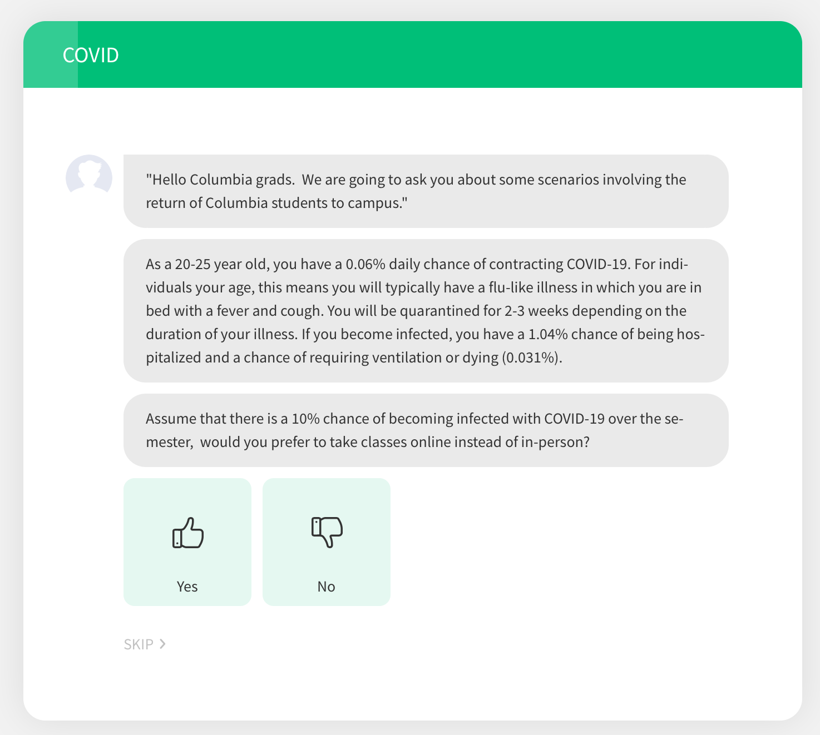

If students were willing to accept a 10% risk (answering ‘No’), they were presented with an incremental 5% increase in risk of infection until they felt that the trade-off was not worth the risk. The risk maxed out at 100%, indicating that students who accepted this risk, would prefer in-person classes over online classes despite a guarantee of infection. The gamble stopped as soon as the student’s level of risk tolerance was reached by selecting “Yes.” (See **Appendix Figure 3**.)

Conversely, if they rejected the 10% risk, the chance of infection was reduced to 5%, then 1%, 0.5%, 0.1%, 0.05%, and finally 0.001%. If they rejected all of the presented risks, their accepted risk was reported as 0%. Each student’s accepted risk was reported as the average of the highest percent risk they were willing to accept and the lowest percent risk they were unwilling to accept. (See **Appendix Figure 4**.)

**Appendix Figure 3.** Once the student reaches his or her level of risk tolerance, the exercise is stopped, and the next question is asked. Just as with the standard gamble technique deployed to ascertain risk tolerance for in-class exposure to COVID-19, students were asked to make trade-offs between community-level exposures and their willingness to attend parties (bottom of **Appendix Figure 3**.)

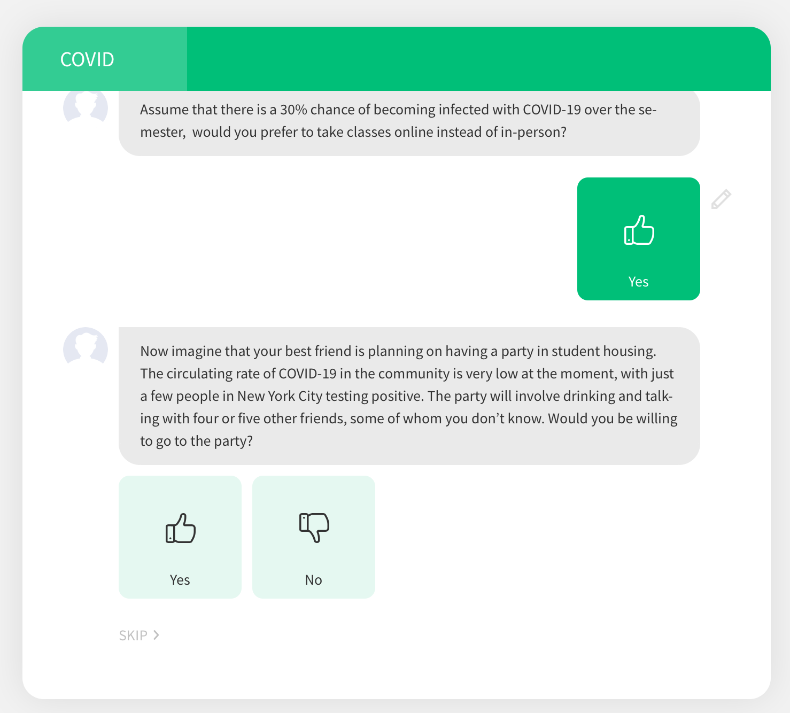

**Appendix Figure 4.** Told that they were to imagine that they faced a given prevalence of infection if they attended classes in person, students underwent a gamble in which their risk tolerance for in-person class time was assessed. Many students were willing to face a significant risk of infection in exchange of taking classes in-person.

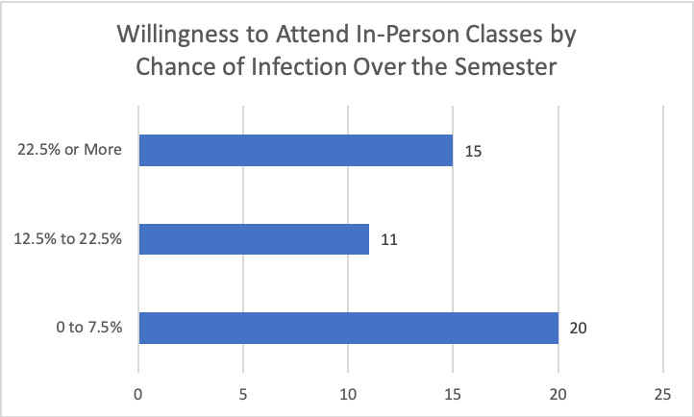

**Willingness to attend a party at different incidence levels of COVID-19**

Next, participants were presented with a scenario in which their best friend was planning a social gathering off-campus in an environment where the prevalence of circulating virus in the community was very low, with just a “few people” testing positive. The social gathering involved “drinking and talking” with 4-5 people whom they did not know.

They were first asked whether they would be willing to go to the social gathering under this low risk setting. If the student answered ‘Yes’, then the prevalence of COVID-19 was increased to medium but not negligible (a “few hundred people”) and then to high (a “few thousand people”). At that point, the exercise was stopped.

If the student was not willing to go to a social gathering under the low risk setting, they were reported to have no willingness to attend social gatherings. If they accepted only the low risk setting, rejecting the higher risk settings, they were reported to be willing to accept low risk of infection to attend a social gathering. If they also accepted the next risk (low but not negligible), they were reported to accept a medium risk of infection. If they accepted the risk in all scenarios, they were reported to accept high risk of infection. (See **Appendix Figure 5**.)

**Appendix Figure 5**. Out of 35 students reporting, only 16 graduate students in public health said that they would not attend any parties over the semester that involved 4-5 people drinking in a room. 7 indicated that they would be willing to attend a party even if the prevalence of COVID-19 in the community was very high.

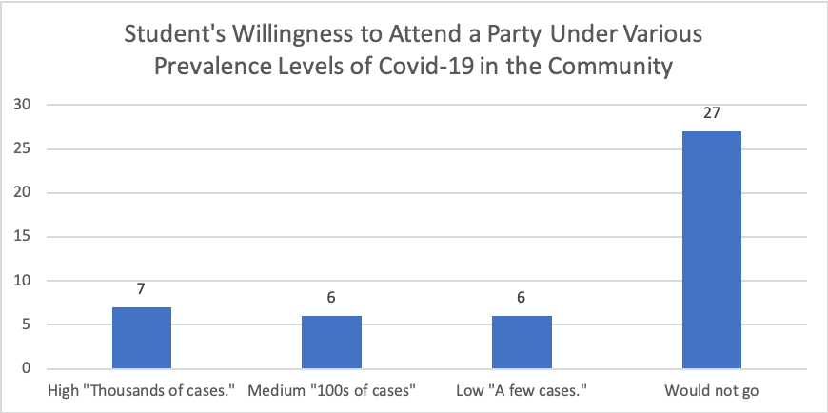

Next, the students were queried as to how many times per week that they were planning on leaving the campus by subway, dining in restaurants, and engaging in other activities that may put them in close contact with non-Columbia University affiliates. (See **Appendix Figure 5**.)

**Appendix Figure 5.** The number of times students plan to leave campus per week to take the subway or eat.

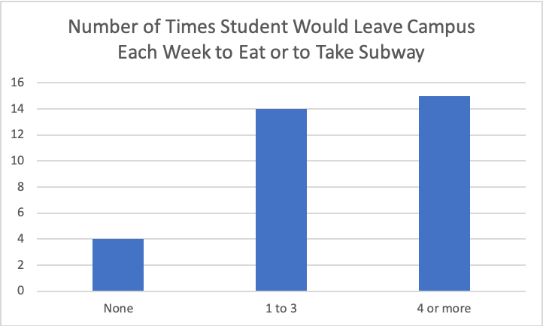

Finally, the students were presented with the average tuition paid per year at Columbia University ($20,000, a figure rounded down to the nearest $10,000 increment). They were then asked how much they would be willing to pay for classes per year given that they were online instead. (See **Appendix Figure 6**.)

**Appendix Figure 6.** Told that they were to imagine that they were paying $20,000 in tuition out-of-pocket, students were asked to simply report the value that they would be willing to pay in the event that all classes were held online.

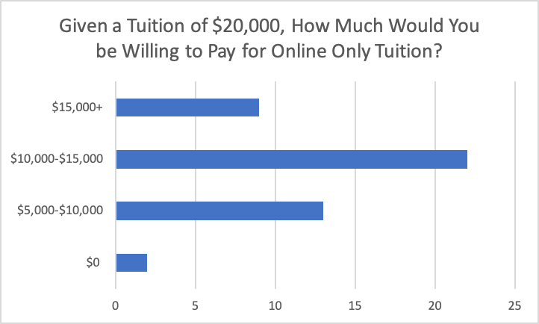

The raw data are presented **in Appendix Table 2**.

**Appendix Table 2**

|  |  |  |  |
| --- | --- | --- | --- |
| **Average Risk of Infection accepted until preference of Online Class** | **Students willing to attend social gatherings given Low/Moderate prevalence of COVID-19 in NYC** | **Average Annual Tuition willing to pay for Online Classes** | **Average Number of times per week going off-campus** |
| **23%** | **28%** | **$9,818** | **3.6** |

|  |  |  |  |
| --- | --- | --- | --- |
| **Average Risk of Infection accepted until preference of Online Class** | **Willingness to attend social gatherings** | **Number of times per week going off campus** | **Average Annual Tuition willing to pay for Online Classes** |
| 0.125 | No | 0.5 | 9050 |
| 0.125 | Low | 5 | 10000 |
| 0.03 | No | 4 | 7000 |
| 0.003 | No | 2 | 10000 |
| 0.475 | Low | 6 | 10000 |
| 0.175 | Medium | 10 | 10000 |
| 0.0075 | No | 1 | 16000 |
| 0.275 | No | 2 | 5000 |
| 0.03 | No | 1 | 15000 |
| 0 | No | 10 | 17000 |
| 0.175 | No | 5 | 10000 |
| 0.175 | High | 3 | 10000 |
| 0.075 | High | 8 | 7500 |
| 0.225 | No | 2 | 15000 |
| 0.03 | Medium | 3 | 17000 |
| 0.003 | No | 1 | 5000 |
| 0.075 | No | 2 | 12000 |
| 0.375 | No | 2 | 8000 |
| 0.775 | Medium | 5 | 10000 |
| 0.175 | Medium | 10 | 10000 |
| 0.575 | No | 4 | NA |
| 1 | No | 1 | 0 |
| 0.125 | No | 3 | 10000 |
| 0.075 | No | 0 | 15000 |
| 0.375 | Low | 1 | 10000 |
| 0.003 | No | 0 | 5000 |
| 0.125 | Low | 3 | 5000 |
| 0.175 | Medium | 2 | 10000 |
| 0.03 | Low | 2 | 10000 |
| 0.725 | No | 0 | 5000 |
| 1 | High | 4 | 10000 |
| 0.125 | Medium | 3 | 10000 |
| 0.0075 | No | 1 | 8000 |
| 0.175 | Low | 4 | 10000 |
| 0.003 | No | 0 | 10000 |
| 0.875 | High | 3 | 10000 |
| 0.03 | No | 1 | 10000 |
| 0.225 | No | 3 | 10000 |
| 0.0075 | High | 2 | 10200 |
| 0.03 | No | 2 | 15050 |
| 0.275 | High | 2 | 15000 |
| 0.225 | High | 7 | 15000 |
| 0.003 | No | 5 | 5000 |
| 1 | No | 21 | 10000 |
| 0.03 | No | NA | 5000 |
| 0.075 | No | 4 | 5000 |

**Sample of Survey Questions**

“Assume that there is a 10% chance of becoming infected with COVID-19 over the semester, would you prefer to take classes online instead of in-person?”

“Now imagine that your best friend is planning on having a party in student housing. The circulating rate of COVID-19 in the community is very low at the moment, with just a few people in New York City testing positive. The party will involve drinking and talking with four or five other friends, some of whom you don’t know. Would you be willing to go to the party?”

“Approximately, how many times a week do you plan to leave the Columbia campus and spend time in the general New York City area, possibly interacting with non-Columbia affiliates (riding the subway, eating at restaurants, etc.)?”

“Imagine that you are paying tuition out of pocket, and the annual tuition for online classes is $20,000. All things being equal (you remain in your New York housing and obtain a degree from Columbia University), how much would you be willing to pay if the courses were only available on Zoom as opposed to in-person?

Input value between 0 and 20,000”

**D. Additional model outcomes**

Here, we present probabilistic analyses as well as additional model sensitivity analyses.

In **Appendix Figure 7**, we see that variance for enhanced, 2-ply masks and symptom-checking applications is much smaller than for other interventions. This suggests a higher degree of certainty that these approaches accurately predict outcomes.

Expenditures for the enhanced, 2-ply mask strategy are above and beyond those in the CDC guidelines, which also includes expenditures for disposable surgical masks. We assume that universities will purchase these additional masks for affiliates who come to work forgetting their mask, with a dirty or damaged mask, or who simply do not wish to wear a generic mask with a university logo on it. We did not reduce expenditures associated with purchasing other masks. Were we to do so, this strategy would intuitively be more cost-effective than the others because the mask is of equal or greater efficacy than what is generally worn by the public, but also comes at a slightly higher price.

**Appendix Figure 7**. The cost-effectiveness plane representing difference in costs vs. difference in QALYs for multiple interventions of our model compared to the CDC guidelines (depicted at prevalence rate of 131 infectious cases among 100,000 people).

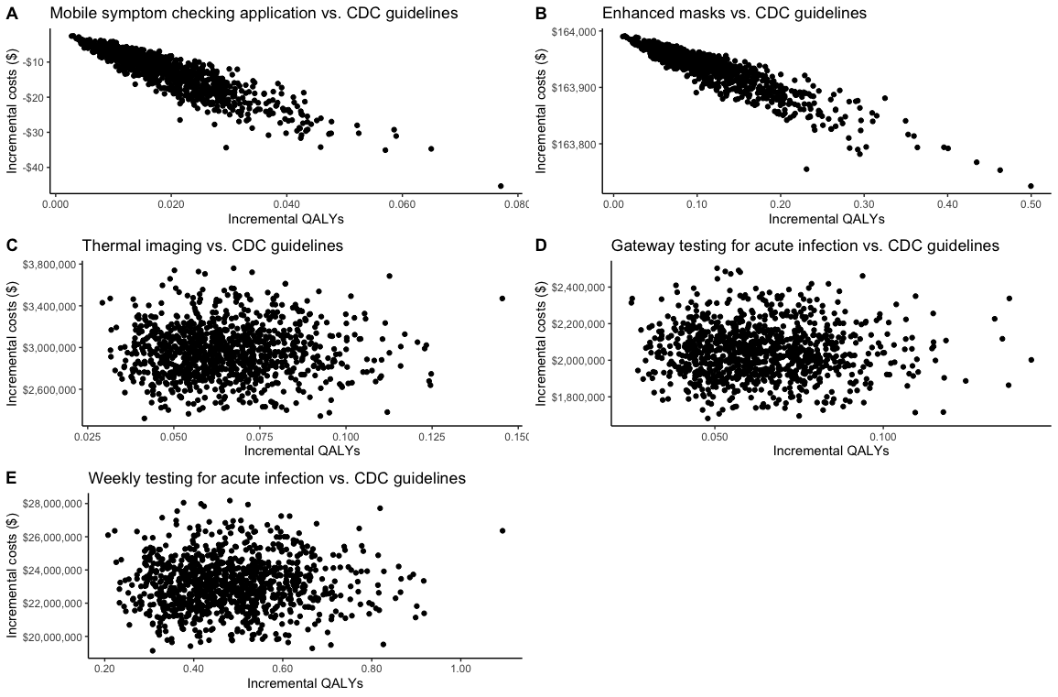

We conducted a number of multi-way sensitivity analyses. **Appendix Figure 8** and **Appendix Figure 9** show the important relationship between the prevalence of actively infectious cases in the community, number of contacts between students off campus (including housing), and the transmission rate. At a prevalence rate of 0.1%, varying the number of contacts and the transmission rate does not have much influence on the ranking of the preferred prevention strategies. However, at a prevalence rate of 1%, we see a gradual shift toward the weekly testing option as the number of close contacts between students rises and the transmission rate rises.

This is important because both the number of contacts and the transmission rate will likely be higher for colleges and universities in which a large proportion of the student body commutes from multi-generational households to school.

**Appendix Figure 8**. Three-way sensitivity analysis examining the relationship between the number of close contacts between students on campus, the transmission rate per close student contact, and willingness-to-pay for the top 3 intervention strategies at a 0.1% prevalence rate of actively infectious cases in the community.

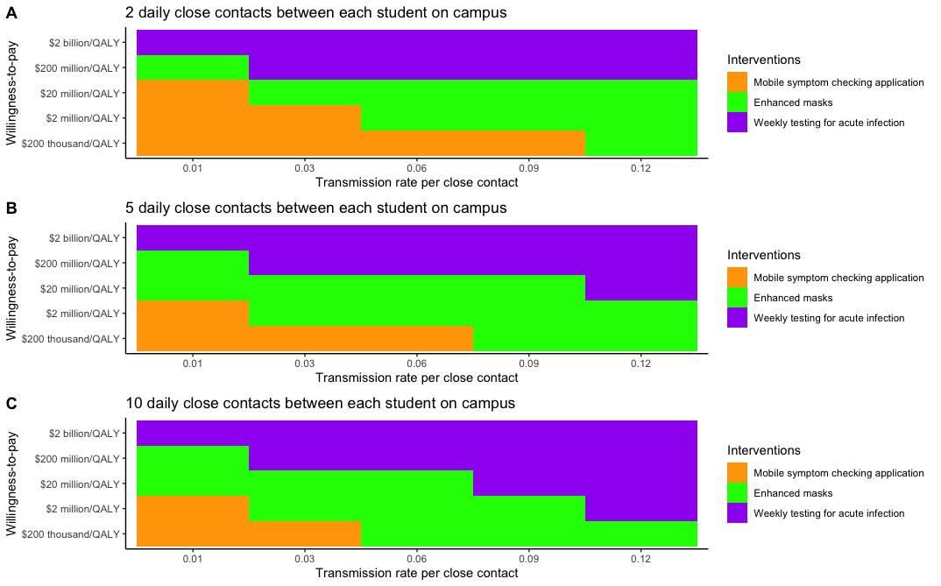

**Appendix Figure 8**. Three-way sensitivity analysis examining the relationship between the number of close contacts between students on campus, the transmission rate per close student contact, and willingness-to-pay for the top 3 intervention strategies at a 0.1% prevalence rate of actively infectious cases in the community.

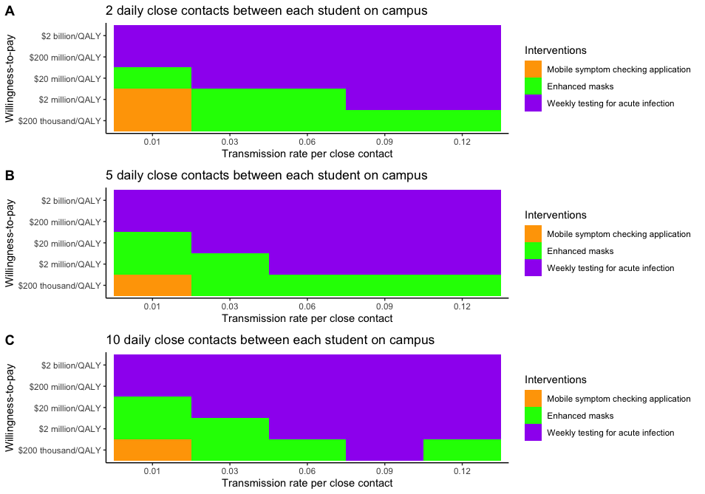

**Appendix Figure 10** shows that despite conservative assumptions surrounding the cost and use of university-provided 2-ply masks, the strategy competes for dominance with the symptom-checking application intervention.

**Appendix Figure 8.** Multi-way sensitivity analysis. The dominant strategy is shown at different willingness-to-pay (WTP) ratios when compliance with mask wearing is compared with the prevalence of active infectious cases. Enhanced, 2-ply masks and the symptom-checking application compete for dominance depending on the prevalence of active infectious cases.

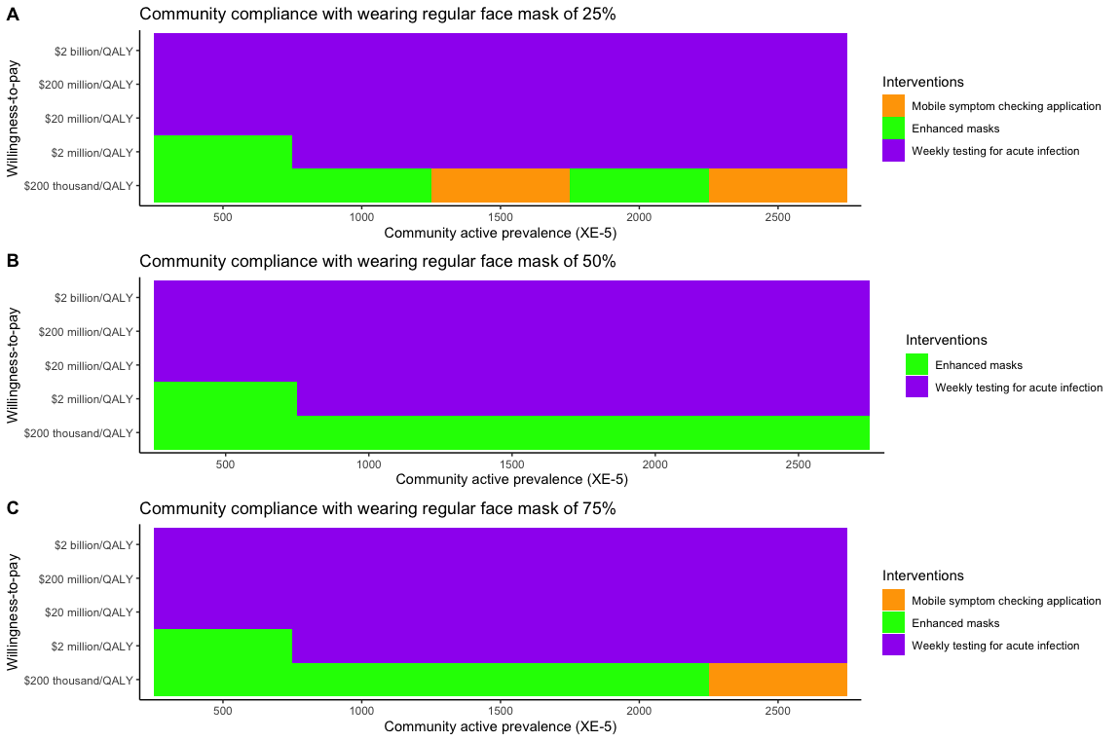

In **Appendix Figure 9**, we see that, once again, university-provided 2-ply reusable masks and the symptom-checking application are dominant strategies unless the WTP for other interventions is very high. This higher WTP may be reasonable if the university can afford to do so because COVID-19 provides a greater existential threat than diseases and conditions such as diabetes. Higher WTP thresholds are commonly seen for preventing threats such as nuclear accidents or aviation disasters.30

**Appendix Figure 9.** Cost-effectiveness acceptability curves. The probability of cost-effectiveness (with maximum net monetary benefit) for multiple interventions at different willingness-to-ay values (calculated at base-case prevalence of 131 cases/100,000 population).

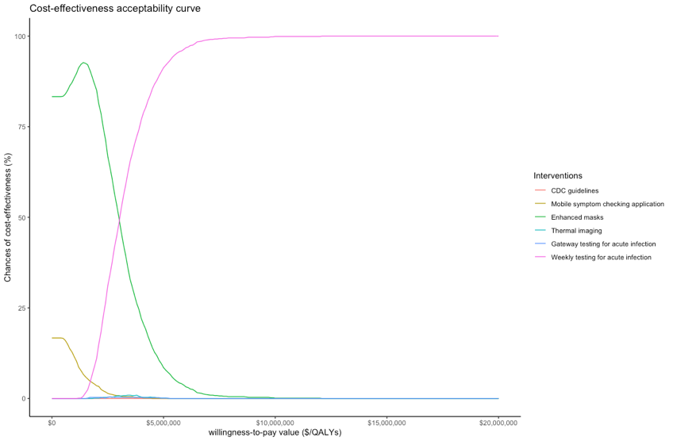

**References**

1. Bi Q, Wu Y, Mei S, et al. Epidemiology and transmission of COVID-19 in 391 cases and 1286 of their close contacts in Shenzhen, China: a retrospective cohort study. *The Lancet Infectious Diseases.* 2020.

2. Cneters for Disease Control and Prevention. Large-scale Geographic Seroprevalence Surveys. Availale online at: <https://www.cdc.gov/coronavirus/2019-ncov/cases-updates/geographic-seroprevalence-surveys.html> Accessed 8/05/2020.

3. He X, Lau E, Wu P, et al. April 2020, posting date. Temporal dynamics in viral shedding and transmissibility of COVID-19. *Nat Med doi.*10.

4. World Health Organization. Available online at: <https://www.who.int/docs/default-source/coronaviruse/situation-reports/20200402-sitrep-73-covid-19.pdf?sfvrsn=5ae25bc7_2#:~:text=The%20incubation%20period%20for%20COVID,occur%20before%20symptom%20onset> Accessed 8/5/2020.

5. Sakurai A, Sasaki T, Kato S, et al. Natural History of Asymptomatic SARS-CoV-2 Infection. *N Engl J Med.* 2020.

6. Chen X, Hazra DK. Understanding the Bias between the Number of Confirmed Cases and Actual Number of Infections in the COVID-19 Pandemic. *medRxiv.* 2020.

7. Centers for Disease Control and Prevention. COVID-NET. COVID-19 Laboratory-Confirmed Hospitalizations. Available online at: <https://gis.cdc.gov/grasp/COVIDNet/COVID19_5.html>. Accessed 8/6/2020.

8. Katz J, Katz MS, Quealy K. A detailed map of who is wearing masks in the U.S. Available online at: <https://www.nytimes.com/interactive/2020/07/17/upshot/coronavirus-face-mask-map.html> Accessed 7/28/2020. 2020.

9. Arp NL, Nguyen TH, Graham Linck EJ, et al. Use of face coverings by the public during the COVID-19 pandemic: an observational study. *medRxiv.* 2020:2020.2006.2009.20126946.

10. Avalere. COVID-19 Hospitalizations Projected to Cost up to $17B in US in 2020. Available online at: <https://avalere.com/insights/covid-19-hospitalizations-projected-to-cost-up-to-17b-in-us-in-2020>. Accessed 8/6/2020.

11. Bartsch SM, Ferguson MC, McKinnell JA, et al. The Potential Health Care Costs And Resource Use Associated With COVID-19 In The United States: A simulation estimate of the direct medical costs and health care resource use associated with COVID-19 infections in the United States. *Health Aff (Millwood).* 2020:10.1377/hlthaff. 2020.00426.

12. Centers for Disease Control and Prevention. Reopening Guidance for Cleaning and Disinfecting Public Spaces, Workplaces, Businesses, Schools, and Homes. Available online at: <https://www.cdc.gov/coronavirus/2019-ncov/community/reopen-guidance.html> Accessed 7/16/2020.

13. Association of School Business Associates International. What will it cost to re-open schools? Available online at: <https://www.asbointl.org/asbo/media/documents/Resources/covid/COVID-19-Costs-to-Reopen-Schools.pdf> Accessed 8/3/2020.

14. Jefferson T, Foxlee R, Del Mar C, et al. Physical interventions to interrupt or reduce the spread of respiratory viruses: systematic review. *BMJ.* 2008;336(7635):77-80.

15. Chu DK, Akl EA, Duda S, et al. Physical distancing, face masks, and eye protection to prevent person-to-person transmission of SARS-CoV-2 and COVID-19: a systematic review and meta-analysis. *The Lancet.* 2020.

16. Broad Institute. Fall college testing program. Available online at: <https://covid-19-test-info.broadinstitute.org/safe-for-school/>. Accessed 8/6/2020.

17. Quilty BJ, Clifford S, Flasche S, Eggo RM. Effectiveness of airport screening at detecting travellers infected with novel coronavirus (2019-nCoV). *Eurosurveillance.* 2020;25(5):2000080.

18. Priest PC, Duncan AR, Jennings LC, Baker MG. Thermal image scanning for influenza border screening: results of an airport screening study. *PLoS One.* 2011;6(1):e14490.

19. Briggs A. Moving beyond “lives saved” from COVID-19. Available online at: <https://avalonecon.com/moving-beyond-lives-saved-from-covid-19/>. Accessed 8/5/2020.

20. Endo A, Abbott S, Kucharski AJ, Funk S. Estimating the overdispersion in COVID-19 transmission using outbreak sizes outside China. *Wellcome Open Research.* 2020;5(67):67.

21. Muennig P, Zafari Z. OpenUp Model. Mailman School of Public Health. Columbia University. Available online at: <https://www.publichealth.columbia.edu/academics/departments/health-policy-and-management/openup-model> Accessed 8/2/2020. 2020.

22. Liu D, Clemente L, Poirier C, et al. A machine learning methodology for real-time forecasting of the 2019-2020 COVID-19 outbreak using Internet searches, news alerts, and estimates from mechanistic models. *arXiv preprint arXiv:200404019.* 2020.

23. Lustig SR, Biswakarma JJH, Rana D, et al. Effectiveness of Common Fabrics to Block Aqueous Aerosols of Virus-like Nanoparticles. *ACS nano.* 2020;14(6):7651-7658.

24. Somsen GA, van Rijn C, Kooij S, Bem RA, Bonn D. Small droplet aerosols in poorly ventilated spaces and SARS-CoV-2 transmission. *The Lancet Respiratory Medicine.* 2020.

25. Buonanno M, Welch D, Shuryak I, Brenner DJ. Far-UVC light (222 nm) efficiently and safely inactivates airborne human coronaviruses. *Sci Rep.* 2020;10(1):1-8.

26. Sublett JL. Effectiveness of air filters and air cleaners in allergic respiratory diseases: a review of the recent literature. *Curr Allergy Asthma Rep.* 2011;11(5):395.

27. Courtemanche C, Garuccio J, Le A, Pinkston J, Yelowitz A. Strong Social Distancing Measures In The United States Reduced The COVID-19 Growth Rate: Study evaluates the impact of social distancing measures on the growth rate of confirmed COVID-19 cases across the United States. *Health Aff (Millwood).* 2020:10.1377/hlthaff. 2020.00608.

28. Cadet J. Harmless Effects of Sterilizing 222‐nm far‐UV Radiation on Mouse Skin and Eye Tissues. *Photochem Photobiol.* 2020.

29. Yang W, Kandula S, Huynh M, et al. Estimating the infection fatality risk of COVID-19 in New York City, March 1-May 16, 2020. *medRxiv.* 2020:2020.2006.2027.20141689.

30. Tengs TO, Adams ME, Pliskin JS, et al. Five-hundred life-saving interventions and their cost-effectiveness. *Risk Anal.* 1995;15(3):369-390.